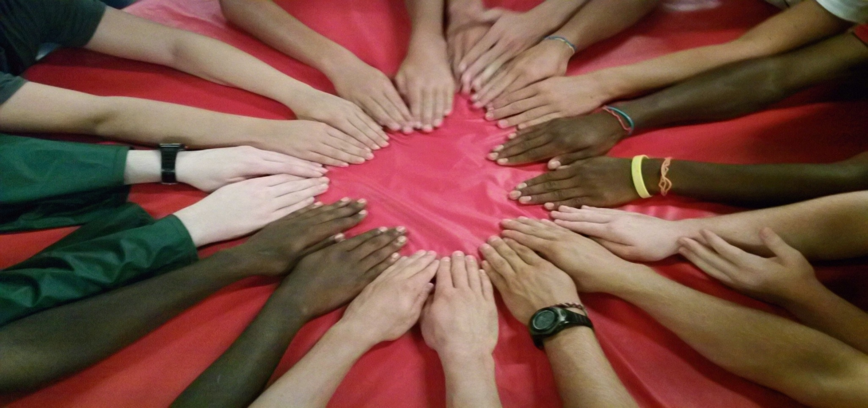

**CONTACT: JILL WADDELL** [**campweekaneatit@gmail.com**](mailto:campweekaneatit@gmail.com) **770.312.9722**

**Camp Weekaneatit** looks like any other summer camp. You can hear the laughter…You wouldn't know it from looking at them, but all of our campers have celiac disease and gluten intolerance. They're just kids, having the time of their lives at a camp designed especially for them. The vision of Camp Weekaneatit was to create a camp exclusively for celiac children, where not only could they experience all of the fun that comes with camp activities, but all food would be gluten free!

**What:** Summer residential camp for children ages 8-17 with CELIAC DISEASE and GLUTEN INTOLERANCE.

**When:** May 29 – June 3, 2016

(Volunteers are to arrive on May 28, 2015 Wishing you a Happy Thanksgiving!  We are most grateful for YOU for bringing joy to our campers and to camp and for taking time out of your busy life to share yourself with CCFA!

Its a perfect time for you to commit to Camp 2016.

We have set the date for the 2016 CCFA Camp Oasis at Camp Twin Lakes, Camp Will A Way for:

Saturday, June 18, 2016 - Friday, June 24, 2016

Please let me know if you are interested in being a volunteer for 2016, and I will get back to you!

I would love your help in recruiting new and enthusiastic, caring, leaders to volunteer with our program.  If you have a good forum to make a presentation on our behalf, let me know--I will get you the tools to make it successful.

In Camp Spirit,

Jill Waddell

CCFA Camp Oasis

[Blue Twigs Consulting](http://www.bluetwigs.com/)

[Out Loud Retreats](http://www.outloudretreats.com/)

bluetwigs@gmail.com

770.312.9722

)

**Where:** Camp Twin Lakes (CTL) - Camp Dream site in Warm Springs, Georgia.

For more information and an application, go to [www.glutenfreecamp.org](http://www.glutenfreecamp.org)



**CAMPERS AGES 8 – 17**

**APPLY AT:** [**WWW.GLUTENFREECAMP.ORG**](http://WWW.GLUTENFREECAMP.ORG)

**ALSO Seeking Volunteer COUNSELORS AND MEDICAL TEAM MEMBERS**

To apply: contact: Jill Waddell: [campweekaneatit@gmail.com](mailto:campweekaneatit@gmail.com)

**Gluten Free Camp for youth with Gluten Intolerance and Celiac disease**

**GLUTEN FREE SUMMER CAMP OPPORTUNITY**